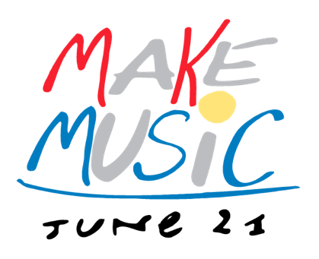

<Company> Celebrates Make Music Day with <Event>
<Free Event> brings global day of music to <town/community name>

WHAT: <Company> opens its doors for <event> in celebration of Make Music Day, a global event taking place in over 750 cities around the world. <Insert detail sentence about event (mention performers, music-making opportunities, etc).> Make Music Day is a day of music open to all in the streets, businesses, parks, and wherever people feel like playing or listening. <Company’s event> joins other events worldwide as communities come together in celebration of music and the countless benefits that making music brings.

WHO: <Company, Company tagline if needed, any involved community partners (for example, local performers, band, children’s group)>

WHEN: Make Music Day, Wednesday, June 21, <TIME span>

WHERE: <Location, address, city>

WHY: <Company> celebrates Make Music Day, giving community members of all ages, creeds, and musical persuasions the chance to experience the joy of making music together. <Insert simple sentence about Company’s commitment to music, the benefits of music, and service to the community>

By establishing one specific day each year, June 21, to celebrate music, <company> encourages both amateur and professional music making, and empowers individuals to seek out ways to celebrate music in their community.

WHAT ELSE: For more information about <Company Event>, please contact <Phone, web address, etc.>

<Company Contact Information>

About <Company>

About Make Music Day:
Held annually on June 21, Make Music Day is part of the international Fête de la Musique, taking place in 750 cities across 120 countries. The daylong, musical free-for-all celebrates music in all its forms, encouraging people to band together and play in free public concerts. This year, more than 50 U.S. cities are organizing Make Music Day celebrations, encompassing thousands of concerts nationwide. Make Music Day is presented by the NAMM Foundation, and coordinated by the Make Music Alliance. For more information, please visit www.makemusicday.org.
###

